# **Name: Abdurrahman Qureshi**

# **Roll No: 210451**

Practical No: 14

**1) Write a program to show a dropdown menu**

**CODE:**

<!DOCTYPE html>  
<html lang="en">  
<head>  
 <meta charset="UTF-8">  
 <title>Title</title>  
 <style>  
 body {  
 font-family: -apple-system, sans-serif;  
 }  
 #myMenu {  
 display: none;  
 width: 10rem;  
 }  
 #myMenu ul li {  
 font-size: 1.5rem;  
 }  
 </style>  
</head>  
<body>  
<div id="menuTrigger" onclick="toggleDropDown()">  
 <h1>Menu</h1>  
</div>  
<div id="myMenu">  
 <ul>  
 <li>Home</li>  
 <li>About</li>  
 <li>Contact</li>  
 <li>Settings</li>  
 </ul>  
</div>  
<script>  
 let ***myMenu*** = ***document***.getElementById("myMenu");  
 let ***toggling*** = false;  
 function toggleDropDown() {  
 ***toggling*** = !***toggling*** if (***toggling***){  
 ***myMenu***.style.display = "block"  
 } else {  
 ***myMenu***.style.display = "none"  
 }  
 }  
</script>  
</body>  
</html>

**OUTPUT:**

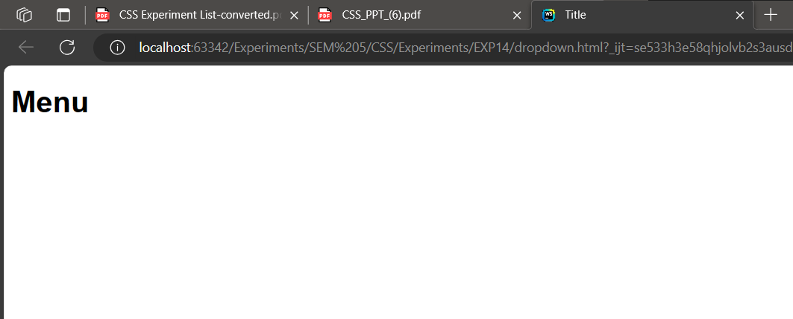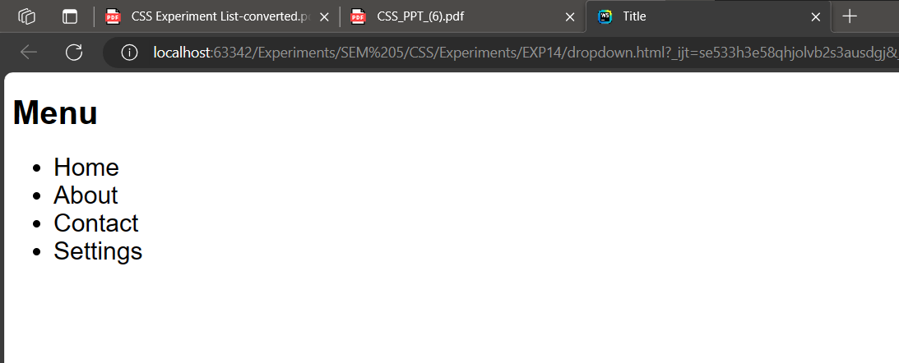

**2) Write a program to display menu when the mouse hovers**

**CODE:**

**<!DOCTYPE html>  
<html lang="en">  
<head>  
 <meta charset="UTF-8">  
 <title>Title</title>  
 <style>  
 body {  
 font-family: -apple-system, sans-serif;  
 }  
 #myMenu {  
 display: none;  
 width: 10rem;  
 }  
 #myMenu ul li {  
 font-size: 1.5rem;  
 }  
 </style>  
</head>  
<body>  
<div>  
 <h1 id="menuTrigger">Menu</h1>  
</div>  
<div id="myMenu">  
 <ul>  
 <li>Home</li>  
 <li>About</li>  
 <li>Contact</li>  
 <li>Settings</li>  
 </ul>  
</div>  
<script>  
 let *myMenu* = *document*.getElementById("myMenu");  
 let *menuTrigger* = *document*.getElementById("menuTrigger");  
*menuTrigger*.addEventListener("mouseover", function () {  
 *myMenu*.style.display = "block";  
 });  
*menuTrigger*.addEventListener("mouseleave", function () {  
 *myMenu*.style.display = "none";  
 });  
</script>  
</body>  
</html>**

**OUTPUT:**

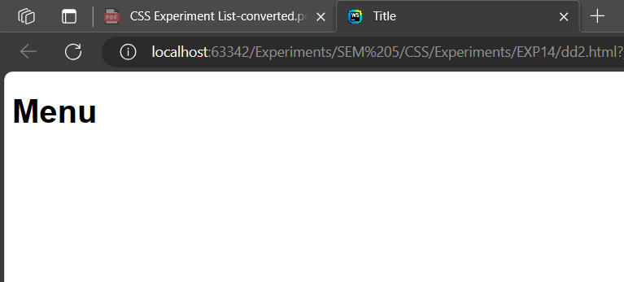

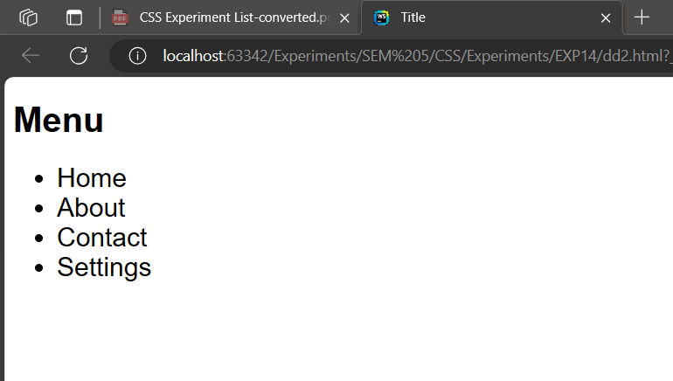

**3) Write a program to show dropdown from navbar**

**CODE:**

<!DOCTYPE html>  
<html lang="en">  
<head>  
 <meta charset="UTF-8">  
 <title>Title</title>  
 <style>  
 body {  
 margin-top: 2rem;  
 font-family: -apple-system, sans-serif;  
 }  
 #myMenu {  
 display: none;  
 width: 20rem;  
 }  
 #myMenu ul li {  
 font-size: 1.5rem;  
 background-color: #1a1a1a;  
 color: #cccccc;  
 padding: 0.5rem;  
 margin-left: 8.7rem;  
 }  
 span{  
 color: #cccccc;  
 padding: 0.5rem;  
 background-color: #1a1a1a;  
 width: 5rem;  
 height: 3rem;  
 font-size: 2rem;  
 }  
 </style>  
</head>  
<body>  
<div>  
 <span>Title</span>  
 <span>Login</span>  
 <span id="menuTrigger">Menu</span>  
</div>  
<div id="myMenu">  
 <ul>  
 <li>Home</li>  
 <li>About</li>  
 <li>Contact</li>  
 <li>Settings</li>  
 </ul>  
</div>  
<script>  
 let ***myMenu*** = ***document***.getElementById("myMenu");  
 let ***menuTrigger*** = ***document***.getElementById("menuTrigger");  
  
 ***menuTrigger***.addEventListener("mouseover", function () {  
 ***myMenu***.style.display = "block";  
 });  
  
 ***menuTrigger***.addEventListener("mouseleave", function () {  
 ***myMenu***.style.display = "none";  
 });  
</script>  
</body>  
</html>

**OUTPUT:**

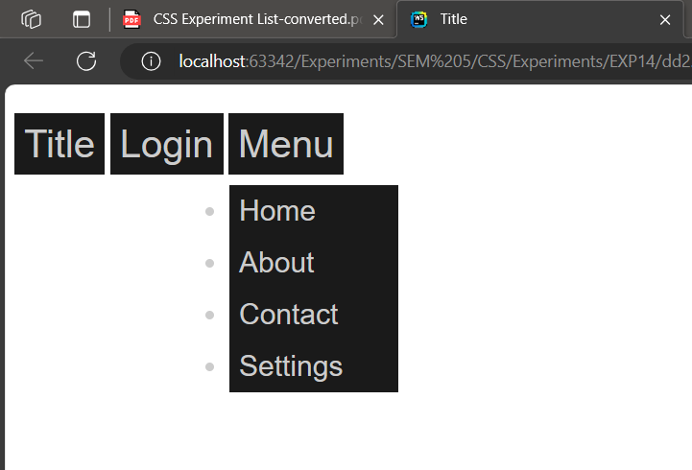

**4) Write a program to show an image in a dropdown**

**CODE:**

<!DOCTYPE html>  
<html lang="en">  
<head>  
 <meta charset="UTF-8">  
 <title>Title</title>  
 <style>  
 body {  
 margin-top: 2rem;  
 font-family: -apple-system, sans-serif;  
 }  
 #myMenu {  
 display: none;  
 width: 20rem;  
 }  
 #myMenu ul li {  
 font-size: 1.5rem;  
 background-color: #1a1a1a;  
 color: #cccccc;  
 padding: 0.5rem;  
 margin-left: 8.7rem; }  
 span{  
 color: #cccccc;  
 padding: 0.5rem;  
 background-color: #1a1a1a;  
 width: 5rem;  
 height: 3rem;  
 font-size: 2rem; }  
 </style>  
</head>  
<body>  
<div>  
 <span>Title</span>  
 <span>Login</span>  
 <span id="menuTrigger">Menu</span>  
</div>  
<div id="myMenu">  
 <img src/EXP16/img/pic2.jpeg" alt="">   
</div>  
<script>  
 let ***myMenu*** = ***document***.getElementById("myMenu");  
 let ***menuTrigger*** = ***document***.getElementById("menuTrigger");  
***menuTrigger***.addEventListener("mouseover", function () {  
 ***myMenu***.style.display = "block";  
 }); ***menuTrigger***.addEventListener("mouseleave", function () {  
 ***myMenu***.style.display = "none";  
 });  
</script>  
</body>  
</html>

**OUTPUT:**

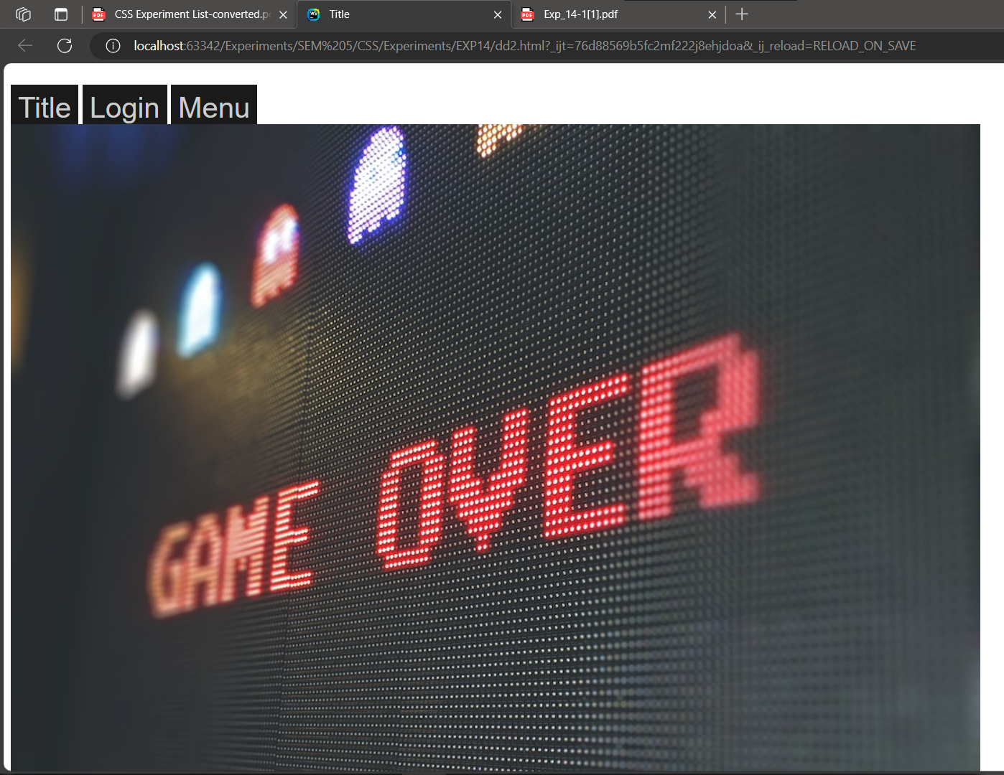

**5) Write a program to show dropdown on a search bar**

**CODE:**

<!DOCTYPE html>  
<html lang="en">  
<head>  
 <meta charset="UTF-8">  
 <title>Title</title>  
 <style>body {  
 margin-top: 2rem;  
 font-family: -apple-system, sans-serif; }  
 #myMenu {  
 display: none;  
 width: 30rem; }  
 #myMenu ul li {  
 font-size: 1.5rem;  
 background-color: #1a1a1a;  
 color: #cccccc;  
 padding: 0.5rem;  
 margin-left: 10rem; }  
 span{  
 color: #cccccc;  
 padding: 0.5rem;  
 background-color: #1a1a1a;  
 width: 5rem;  
 height: 3rem;  
 font-size: 2rem; }  
 </style></head>  
<body><div>  
 <span>Title</span>  
 <span>Login</span>  
 <span>Menu</span>  
 <input type="text" id="menuTrigger">  
</div>  
<div id="myMenu"><ul>  
 <li>Home</li>  
 <li>About</li>  
 <li>Contact</li>  
 <li>Settings</li></ul>  
</div><script>  
 let ***myMenu*** = ***document***.getElementById("myMenu");  
 let ***menuTrigger*** = ***document***.getElementById("menuTrigger"); ***menuTrigger***.addEventListener("focusin", function () {  
 ***myMenu***.style.display = "block"; });  
***menuTrigger***.addEventListener("focusout", function () {  
 ***myMenu***.style.display = "none"; });  
</script></body></html>

**OUTPUT:**

